|  |
| --- |
|  |
| 新概念 3 册 |
| Lesson50 New Year resolutions |



Book

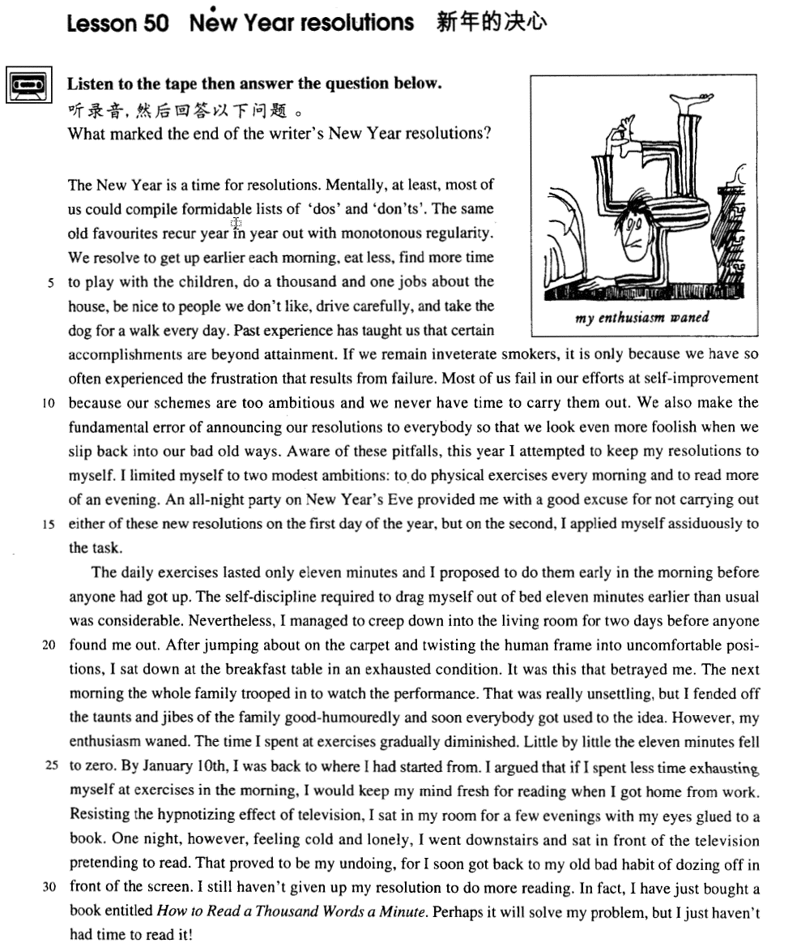

课文

The New Year is a time for resolutions.

新年是下决心的时候，

Mentally, at least, most of us could compile formidable lists of 'dos' and 'don'ts'.

至少在大多数人的心里会编排出一份“应做什么”和“不应做什么”的令人生畏的单子。

The same old favourites recur year in year out with monotonous regularity.

相同的决心以单调的规律年复一年地出现。

We resolve to get up earlier each morning, eat less, find more time to play with the children, do a thousand and one jobs about the house, be nice to people we don't like, drive carefully, and take the dog for a walk every day.

我们决心每天早晨起得早些；吃得少些；多花点时间与孩子们一起做游戏；做大量的家务；对不喜欢的人友善一些；小心驾车；每天都要带着狗散步；等等。

Past experience has taught us that certain accomplishments are beyond attainment.

以往的经验告诉我们有些事是办不到的。

If we remain inveterate smokers, it is only because we have so often experienced the frustration that results from failure.

如果我们烟瘾大，戒不掉，那是因为屡戒屡败，失去信心。

Most of us fail in our efforts at self-improvement because our schemes are too ambitious and we never have time to carry them out.

我们大多数人想自我完善却遭到失败，这是因为我们的规划过于宏大，而又根本没有时间去实施。

We also make the fundamental error of announcing our resolutions to everybody so that we look even more foolish when we slip back into our bad old ways.

我们还犯有一个根本性的错误，即把我们的决心向大家宣布。这样一旦滑回到那些老习惯上去，我们在别人的眼里会显得更加难堪。

Aware of these pitfalls, this year I attempted to keep my resolutions to myself.

我深知这些问题，于是，今年我对自己的计划要严加保密，

I limited myself to two modest ambitions: to do physical exercises every morning and to read more of an evening.

只给自己定下两项适中的任务；每天早上锻炼身体，每天晚上多看点书。

An all-night party on New Year's Eve provided me with a good excuse for not carrying out either of these new resolutions on the first day of the year, but on the second, I applied myself assiduously to the task.

新年除夕举办的一次通宵晚会，使我理直气壮地在新年头一天免去了这两项任务。不过，新年第二天，我全力以赴地照着去做了。

The daily exercises lasted only 11 minutes and I proposed to do them early in the morning before anyone had got up.

早锻炼一共只有11分钟，我打算在别人起床之前进行。

The self-discipline required to drag myself out of bed 11 minutes earlier than usual was considerable.

这就要求我比平时早11分钟把自己从床上拽起来，这种自我约束是很艰苦的。

Nevertheless, I managed to creep down into the living room for two days before anyone found me out.

不过开头两天我还是成功地蹑手蹑脚地来到楼下起居室，被谁也没发现。

After jumping about on the carpet and twisting the human frame into uncomfortable positions, I sat down at the breakfast table in an exhausted condition.

我在地毯上跳来蹦过去，扭曲身子，摆出各种姿势，弄得浑身不舒服，然后坐到桌边吃早饭，一副筋疲力尽的样子。

It was this that betrayed me.

正是这副模样泄露了我的秘密。

The next morning the whole family trooped in to watch the performance.

第二天早晨全家人结队来到起居室看我表演。

That was really unsettling but I fended off the taunts and jibes of the family good-humouredly and soon everybody got used to the idea.

这真叫人不好意思，但我心平气和地顶住全家人的嘲笑和奚落。不久，大家对我习以为常了，

However, my enthusiasm waned.

而这时我的热情却减退了。

The time I spent at exercises gradually diminished.

我花在锻炼上的时间逐渐减少，

Little by little the 11 minutes fell to zero.

慢慢地从11分钟减到了零。

By January 10th, I was back to where I had started from.

到了1月10日，我恢复了原来的作息时间。

I argued that if I spent less time exhausting myself at exercises in the morning, I would keep my mind fresh for reading when I got home from work.

我辩解说，早晨少耗费精力锻炼，晚上下班回家看书时头脑更清醒些。

Resisting the hypnotizing effect of television, I sat in my room for a few evenings with my eyes glued to a book.

有几天晚上，我极力摆脱了电视的诱惑，坐在自己的房间里，两眼盯在书上。

One night, however, feeling cold and lonely, I went downstairs and sat in front of the television pretending to read.

可是，有一天夜里，我感到又冷又孤单，便来到楼下坐在电视机前假装看书。

That proved to be my undoing, for I soon got back to my old bad habit of dozing off in front of the screen.

这下我可完了，因为不一会儿，我就恢复了以前的坏习惯，在屏幕前打起瞌睡来。

I still haven't given up my resolution to do more reading.

但我还没有放弃多看些书的决心。

In fact, I have just bought a book entitled How to Read a Thousand Words a Minute.

事实上，我刚买来一本叫《一分钟读一千字的诀窍》的书。

Perhaps it will solve my problem, but I just haven't had time to read it!

也许这本书能解决我的问题，但我一直还没时间去看这本书！

词汇讲解

* **formidable** ['fɔ:mɪdəbl] adj. 令人望而生畏的

**formidable** / **awesome** adj. 令人望而生畏的

* a / an **formidable** / **awesome** task / challenge

**【辨析】**

**forbidding** adj. 不友好的，冷冰冰的

* a **forbidding** appearance / place
* **recur** [rɪ'kɜ:(r)] v. 再次发生；反复发生
* We must make sure that the problem does not **recur**.
* a **recurring** illness / nightmare

**【扩展】**

**occur** v. 发生 = happen

* When exactly did the incident **occur**?
* Something unexpected **occurred**.

**concur** v. 同意；同时发生

* We strongly **concur *with*** *(=agree with)* the recommendations of this report.
* Everything **concurred** to produce the desired effect.

**incur** v. 招致，引起，带来（不好的结果）

* She had **incurred** the wrath of her father by marrying without his consent.
* **inveterate** [ɪn'vetərət] adj. 根深蒂固的，积习难改的
* an **inveterate** smoker（老烟鬼） / drinker（老酒鬼） / gambler（赌棍） / liar（撒谎成性） （指人）
* If we remain **inveterate smokers**, it is only because we have so often experienced the frustration that results from failure.
* **inveterate** hatred（根深蒂固的仇恨） / prejudice（根深蒂固的偏见） / distrust（根深蒂固的不信任） （指物）
* Hatred is **inveterate** anger. —— M. T. Cicero

**【扩展】【近义词组】**“根深蒂固的”

**deep-seated** / **deep-rooted** （多指事物，不一定指坏事）

* a **deep-seated** / **deep-rooted** bad habit / faith in god

**die hard** 积习难改

* Old habits **die hard**.
* **assiduously** [ə'sɪdjʊəslɪ] adv. 刻苦地

**assiduous** adj. 刻苦的，勤勉的

* an **assiduous** student / researcher

**【词根】**Lesson47、49

“**sid** / **sed**” = sit

as**sid**uous adj. 刻苦的，勤勉的

**sed**ulous adj. 聚精会神的；勤勉的；勤苦工作的

**sed**ative adj. 使镇静的；使安静的

**sed**iment n. 沉积；沉淀物

pre**sid**e vi. 主持，担任会议主席 vt. 管理

pre**sid**ent n. 总统；董事长；校长；主席

re**sid**e vi. 住，居住；属于

re**sid**ence n. 住宅，住处；居住

sub**sid**e vi. 平息；减弱；沉淀；坐下

sub**sid**iary adj. 附属的；辅助的

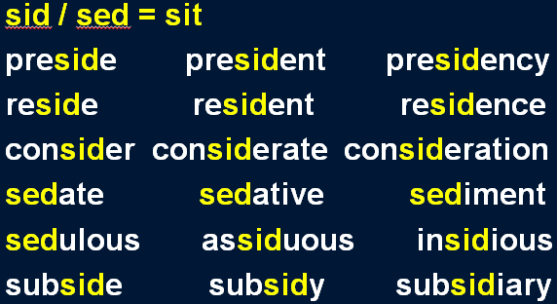

* However, there is an even more **insidious** kind of pollution that particularly affects urban areas and invades our daily lives, and that is noise.
* An all-night party on New Year's Eve, provided me with a good excuse for not carrying out either of these new resolutions on the first day of the year, but on the second, I applied myself **assiduously** to the task.
* I wanna hold you till I die, till we both break down and cry. I wanna hold you till the fear in me **subsides**.
* Aunt Harriet **presided** *over* an invisible army of servants that continuously scrubbed, cleaned, and polished.
* **betray** [bɪ'treɪ] v. 背叛；无意中暴露

**betray** v. **含义1**. 背 叛

* Judas **betrayed** Jesus.
* **betray** one’s beliefs / principles 背叛了信仰/原则

**betray** v. **含义2**. 无意中暴露

* Her voice **betrayed** her nervousness.

**【同根词】**

**betrayal** n. 背叛；辜负；暴露

* Forgetting history means **betrayal**.

**【扩展】**

**cheat on sb.** 背叛某人

* He **cheated on his wife**.

**desert** 抛弃、背叛（Lesson30）

* As he hated army life, he decided to **desert** his regiment.

**be loyal / disloyal to …** 对…的忠诚/不忠诚

**betrayer** / **traitor** / **Judas** 叛徒

* You **Judas**!
* **good-humoredly** ['gʊd'hju:mədli] adv. 心情好地

**good-humored** adj. 心情愉快的；脾气好的

**ill-humored** adj. 坏脾气的，性情恶劣的

**【扩展】**

**humor** = **mood** 心情、情绪；**体液**

* He is in a good / a bad / an ill **humor**.

“体液”比喻性格：

**blood**（多血质，乐观） / **choler**（黄胆汁质，易怒） / **phlegm**（粘液质，冷漠） / **melancholy**（黑胆汁质，忧郁的）

课文讲解

# （标题）

# New Year resolutions

知识点（1）

* 可替换：
* **New Year resolutions**
* **New Year('s) resolutions**
* "Have you made any **New Year's resolutions**?" "
* Yes, I'm going to eat more healthily and give up smoking."

知识点（2）

resolution 决议、决心

* UN **resolution** 联合国决议

# （第一段）

# The New Year is a time for resolutions.

知识点（1）

表达“到了该做某事的时候了”：

**It’s time for sth.**

* **It’s time for** school / dinner / bed.

**It’s time to do sth.**

* **It’s time to** get up.

**It’s (high / about) time (that) ...** (虚拟) 早该做某事

* **It’s (high / about) time (that)** we ***went***home.
* **4级真题：**
* It’s already 5 o’clock now. Don’t you think it’s about time ___C___?

A．we are going home

B．we go home

C．we ***went*** home

D．we can go home

* **考研：**
* If I were in movie, then it would be about time that I ­­­­___D___ my head in my hands for a cry.

(A) bury

(B) am burying

(C) buried

(D) would bury

# Mentally, at least, most of us could compile formidable lists of 'dos' and 'don'ts'.

知识点（1）

**mentally**: **at heart** 在心中

知识点（2）

**compile a list**: **make a list** 列清单

知识点（3）

**dos and don’ts** （名词）应该做和不应该做

**【扩展】**

**likes and dislikes**  （名词）喜欢做的和不喜欢做的事

**ups and downs**  （名词）沉浮

**highs and lows** （名词）兴衰

**ins and outs**  （名词）来龙去脉

# The same old favourites recur year in year out with monotonous regularity.

知识点（1）

**same old ...**（略贬义）司空见惯的、非常熟悉的

* It’s the **same old** story.
* It’s the **same old** excuse.
* It’s the **same old** faces at the meeting.
* 对话：
* “How are you doing?”
* “Same old.”

知识点（2）

**year in year out** = **year after year**  年复一年的

**day in day out** = **day after day** 一天又一天的

**week in week out** = week after week

**month in month out** = month after month

知识点（3）

**with monotonous regularity** （贬义）老是

* The little boy wets the bed **with monotonous regularity**.
* History repeats itself **with monotonous regularity**.

知识点（4）【课文仿写】

* **造句**：这个老问题总是日复一日地重复出现。
* The same old story recurs day in day out with monotonous regularity.

# We resolve to get up earlier each morning, eat less, find more time to play with the children, do a thousand and one jobs about the house, be nice to people we don't like, drive carefully, and take the dog for a walk every day.

**语法分析:**

We resolve to get up earlier each morning（时间状语）（并列1）, eat less（并列2）, find more time to play with the children（目的状语）（并列3）, do a thousand and one jobs about the house（后置定语）（并列4）, be nice to people we don't like（定语从句）（并列5）, drive carefully（并列6）, and take the dog for a walk every day（时间状语）（并列7）.

知识点（1）

表达“**决定做某事**”：

**decide to do ...**

**make up one’s**

**mind to do ...**

**make a decision to do ...**

**determine / resolve to do ...**（正式、书面）

**be resolved / determined to do ...** （正式、书面）

* I **determined to lodge** a complaint as soon as we arrived.

**take the plunge** 长期考虑之后，决定做某事

* If you have been thinking about buying shares, now could be the time to **take the plunge**.

知识点（2）

**a hundred / thousand / million and one** = **very many** 非常多

知识点（3）

表达“**家务**”及相关：

**housework** [U]

**household chores** [C]

* I spent all morning **doing (the) housework / household chores**. 做家务

**do the laundry / washing** 洗衣服

**do / wash the dishes** = **do the washing-up** 洗碗

* **听力真题：**

A．He has to wash a thousand dishes.

B．He has more dishes than his brother.

C．His brother takes too much time **washing the dishes**.

D．He has asked his brother to **wash the dishes** many times.

* W: Have you asked your brother to **do the dishes**?
* M: Thousands of times.
* Q: What does the man mean?
* Answer: (D) He has asked his brother to wash the dishes many times.

知识点（4）

**take the dog for a walk** 遛狗

= **walk the dog**

# Past experience has taught us that certain accomplishments are beyond attainment.

知识点（1）

**experience** [U] 经验

**experience** [C] 经历

知识点（2）Lesson35、41

**be beyond sth.** 无法……；不容……

* The car **is beyond** **repair**. 无法修理
* The rumor **is beyond** **belief**. 无法相信
* The situation **is beyond** **my control**. 无法控制
* The results **are beyond** **dispute / controversy**. 不容争辩
* Her beauty **is beyond** **words / description.** 无法形容
* His conduct **is beyond reproach / criticism**. 无可指摘
* The pain **is beyond** **human endurance**. 无法忍受
* Working with you **is beyond** **my wildest dreams**. 做梦都想不到
* We might say that justice has been done when a man's innocence or guilt has been proved **beyond doubt**. 毫无疑问的

**be beyond sb.** 某人无法理解

= **be a mystery to sb.**

* Why people are prepared to tolerate a four-hour journey each day for the dubious privilege of living in the country **is beyond me**.
* It has always **been a mystery to me** why city dwellers, who appreciate all these things, obstinately pretend that they would prefer to live in the country.
* If we remain inveterate smokers, it is only because we have so often experienced the frustration that results from failure.

# If we remain inveterate smokers, it is only because we have so often experienced the frustration that results from failure.

**语法分析:**

If we remain inveterate smokers（条件状语从句）, it is only *because we have so often experienced the frustration that results from failure（定语从句）*. （*because*... 表语从句）

知识点（1）

表达“老…（人）”：

* an **inveterate** smoker（老烟鬼） / drinker（老酒鬼） / gambler（赌棍） / liar（撒谎成性） （指人）
* old friend 老朋友
* regular / patron 常客
* hardened smuggler 老牌走私犯
* maidservant 老妈子

知识点（2）

**it is because …** 原因是…（主系表）

**the reason is that …** 原因是…

**…, the only reason is that …** 原因是…

~~The reason is because …~~ **☓表达错误**

知识点（3）

**result from ...** 由…导致的（接原因）

= **be caused by**

**【辨析】**

**... result in ..**. 导致（接结果）

= **cause ...**

# Most of us fail in our efforts at self-improvement because our schemes are too ambitious and we never have time to carry them out.

**语法分析:**

Most of us fail *in our efforts at self-improvement（状语）* because our schemes are too ambitious and we never have time to carry them out（原因状语从句).

知识点（1）

**fail to do** 未能做成某事

**fail in one’s efforts / attempts­ +*at … / to do***努力某事，但没有成功

* **造句：**Latham 试图驾机飞跃英吉利海峡，但没有成功。
* Latham **failed in his efforts / attempts to fly** across the English Channel.
* **造句：**考古学家试图要确认被修复的女神像的身份，但没有成功。
* The archaeologists **failed in their efforts / attempts to discover** the identity of the reconstructed statue.
* The archaeologists **failed in their efforts / attempts at the identification** of the reconstructed statue.

知识点（2）

**scheme** n. 1. 计划，方案；2. 阴谋诡计

* **schemes** and intrigues 阴谋诡计

知识点（3）

**never / not get round / around to sth./ doing** 没时间做某事

* It had broken down the previous summer, and though I promised to repair it, **I had never got round to it**.
* **托福听力真题：**

A．It's new.

B．It's dull.

C．It's not clean.

D．It has a broken handle.

* W: I'm having trouble slicing the bread with this knife.
* M: Oh. Sorry about that. I have**n't gotten around to sharpening** it yet.
* Q: What can be inferred about the knife?
* Answer: (B) It’s dull.

知识点（4）

**carry sth. ↔ out** 执行，实施

* We **carried out** her instructions precisely.

# We also make the fundamental error of announcing our resolutions to everybody so that we look even more foolish when we slip back into our bad old ways.

**语法分析:**

We also make the fundamental error *of announcing our resolutions to everybody（后置定语）* **so that**（结果状语从句） we look even more foolish when we slip back into our bad old ways（时间状语从句）.

知识点（1）

**fundamental** adj. 根本性的

* **fundamental** error / mistake
* **fundamental** change / difference

**make the fundamental error of doing sth.** 犯了根本性的错误

* **造句**：他犯了轻敌这个根本性的错误。
* He **made the fundamental error of** despising his enemy.

知识点（2）Lesson43

**语法：so (that) 作连词时一般来说有两种用法**：

1. 引导结果状语从句，译为“所以”，从句谓语动词中一般没有情态动词。

2. 引导目的状语从句，译为“以便”= in order that …，从句谓语动词中多出现情态动词 can, could, may, might, should, would 等。

* Drive carefully **so that** everyone ***can***enjoy a long life. （以便）
* We paid him immediately, **so (that)** he left contented. （所以）
* We paid him immediately, **so (that)** he would leave contented. （以便）
* The pie committee decided that the best way to transport the dish would be by canal, **so**（所以） they insured it for the trip.
* In the new country he became absorbed in making a new life for the two of us, **so that** （所以）he gradually ceased to grieve.
* It had been purchased by a local authority **so that** （以便）an enormous pie **could** be baked for an annual fair.
* This time they fixed heavy metal clamps to both sides of the dish **so that** （以便）they **could** fasten the chains.

知识点（3）Lesson29

**slip** 滑到

* He was still mumbling something about hospitals at the end of the party when he **slipped** on a piece of ice and broke his left leg.

**slip into … 英文解释：**to gradually start to be in a bad state or situation 渐渐陷入某种不良状态

* **slip into debt** / **unconsciousness** … 渐渐陷入债务/昏迷
* He had begun to **slip into debt**.
* She **slipped into unconsciousness** and died the next day.
* The country is **slipping into recession**. 渐渐陷入萧条

# Aware of these pitfalls, this year I attempted to keep my resolutions to myself.

**语法分析:**

（being）Aware of these pitfalls（非谓语动词做原因状语), this year I attempted to keep my resolutions to myself.

知识点（1）

**pitfall** n. **英文解释：**a likely mistake or problem in a situation 易犯的错误，易出现的问题

* the potential **pitfalls** of buying a house
* Her advice helped me avoid some of the common **pitfalls**.

知识点（2）

**keep sth. to oneself** 保密

= **keep sth. secret**

* I **keep** my love for Helen **to myself**.

**keep sth. from sb.** 向某人保密

* The only other people who knew the secret were Joe and Bob. They did **not** even **tell** their wives.
* They even **kept it from their wives**.

**【扩展】【反义】**

**reveal a secret** 揭示秘密

**a secret becomes known** 秘密被知晓

# I limited myself to two modest ambitions: to do physical exercises every morning and to read more of an evening.

知识点（1）

**modest** adj. 些许的；不太大（或贵、重要等）的

知识点（2）

**limit oneself to sth.** 给自己限定……

* I **limit myself to** 2 glasses of beer a day.
* She **limits herself to** 1,000 calories a day to lose weight.

知识点（3）

**do (physical) exercises** 锻炼身体

知识点（4）

**of an evening / of a weekend ...**【英】【习语】

= i**n the evenings / at weekends ...**

# An all-night party on New Year's Eve provided me with a good excuse for not carrying out either of these new resolutions on the first day of the year, but on the second, I applied myself assiduously to the task.

**语法分析:**

An all-night party *on New Year's Eve* provided me with a good excuse **for**（**for**... 后置定语,修饰excuse） not carrying out either of these new resolutions on the first day of the year（时间状语）, but *on the second（时间状语）*, I applied myself assiduously to the task.

知识点（1）

***on* … Eve** 重要日子的前一夜

知识点（2）

**provide sb. with sth.** 为某人提供某事

**an excuse *for* (doing) sth.** 做某事的借口

**sth. provide sb. with a good excuse for (doing) sth.** 某事为某人提供了借口做…

* **造句**：突然得病使他有借口没有参加会议。
* A sudden illness **provided him with a good excuse for not attending** the meeting.
* **造句**：漫长辛苦的旅程使我有借口很早去睡觉。
* A long and arduous journey **provided me with a good excuse for going** to bed early.

**【复习】**

* Lesson46
* **plead** ignorance（不知道） / illness（生病） / a headache（头疼） / tiredness（疲劳） / insanity（精神失常） 以…为借口

知识点（3）

**either of …**  两个中任何一个……

**each of …**  三个以上中任何一个……

**neither of …** 两个都不……

**none of …** 三个以上都不……

**both of …**  两个都……

**all of …**  三个以上都……

知识点（4）

**apply oneself to sth.** 努力、致力去做

= **work hard at sth.**

* **造句：**近来我一直在努力地学习英语。
* Recently I have been **applying myself assiduously to** studying English.

# （第二段）

# The daily exercises lasted only 11 minutes and I proposed to do them early in the morning before anyone had got up.

The daily exercises lasted only eleven minutes and I proposed to do them early in the morning before anyone had got up（时间状语从句）.（early…时间状语）

知识点（1）

propose v. **英文解释：**(fml.) to intend to do something 打算

**propose to do sth.** 打算做某事

* How do you **propose *to deal* with** the situation?

**propose doing sth.** 打算做某事

* How do you **propose *getting***home?

# The self-discipline required to drag myself out of bed 11 minutes earlier than usual was considerable.

**语法分析:**

The self-discipline ***required*** *to drag myself out of bed eleven minutes earlier than usual（时间状语） （****required****… 后置定语）*was considerable.

知识点（1）

**self-discipline** 自律能力；自我约束能力

知识点（2）【课文仿写】

* **造句**：连续数年 (for years on end) 每天早晨锻炼身体需要很强的自制力。
* The self-discipline *required to do physical exercises every morning for years on end* is considerable.

# Nevertheless, I managed to creep down into the living room for two days before anyone found me out.

知识点（1）Lesson2

**nevertheless / nonetheless / still / all the same / just the same** 尽管如此，还是……

* 'You certainly did give me a surprise!' said the vicar. 'You've probably woken up everyone in the village as well. ***Still***, I'm glad the bell is working again.'
* The girl is not beautiful. **Nevertheless / Nonetheless / Still / All the same / Just the same**, I like her very much.

知识点（2）

**creep** v. 蹑手蹑脚地走

* One bad winter we watched the river **creep** up the lower meadows.

# After jumping about on the carpet and twisting the human frame into uncomfortable positions, I sat down at the breakfast table in an exhausted condition.

**语法分析:**

After（介词短语做时间状语） jumping about on the carpet and twisting the human frame into uncomfortable positions, I sat down at the breakfast table in an exhausted condition（状语、或看成主语补足语）.

知识点（1）

**about / around** adv. 各处, 到处

* As there are so many people **about**, the dogs have to be kept in a special enclosure.

**round about** adv. 在附近，在周围

* **Round about**, piles of limestone glistened in all the colors of the rainbow.

知识点（2）

**twist** v. 转动，扭曲，缠绕

**twist … into …** 把……扭曲、缠绕成……

* We **twisted** the bed sheets into a rope and escaped by climbing down it.

知识点（3）

**frame** n. **英文解释：**human or animal body（人或动物的）身体

* Sobs shook her slender **frame**. 她抽泣着, 苗条的身体都在颤动.

知识点（4）

**语法**：补足语

* **课文写法替换：**
* I sat down at the breakfast table **exhausted** （主语补足语）.
* Inevitably you arrive at your destination almost **exhausted**（主语补足语）.

# It was this that betrayed me.

**语法分析:**

It was this that betrayed me. （强调句）

# The next morning the whole family trooped in to watch the performance.

知识点（1）

**troop** v. 英文解释：to walk somewhere together as a group 成群结队而行

* The bell rings and they all **troop** into school.

# That was really unsettling but I fended off the taunts and jibes of the family good-humouredly and soon everybody got used to the idea.

知识点（1）

**unsettling** adj. 令人不安的

= **disturbing**

**unsettle** v.

= **disturb**

知识点（2）

**fend sb. / sth. ↔ off** 挡开，躲避开，抵御住

* He tried to kiss her but she **fended him off**.
* She managed to **fend off** awkward questions.

知识点（2）

**taunt** 嘲笑

= **jibe / gibe**

* **名词连用：**
* taunts and jibes 讥笑和嘲笑
* aches and pains 这疼那疼
* schemes and intrigues 阴谋诡计
* hustle and bustle 忙忙碌碌

# However, my enthusiasm waned.

知识点（1）

**wane** 1.月亏；**2.**衰落；衰败；败落；减弱

* **wax and wane** 月圆月亏；派生：兴衰、盛衰
* Dynasties **waxed and waned** throughout the history.

**【扩展】**表达“热情减退”：

**ebb (away)** 落潮；退潮

**subside** 回落；减退

* **课文写法替换：**
* However, my enthusiasm **ebbed (away) / subsided**.

# The time I spent at exercises gradually diminished.

知识点（1）

**diminish** [书]: **reduce / decrease**

# Little by little the 11 minutes fell to zero.

知识点（1）

Little by little 同义替换：

**gradually / slowly / little by little / bit by bit / by degrees**

知识点（2）Lesson8

**fall / drop to…** 下降到…

* The temperature **drops to** – 30 〫 and very few people attempt to cross the Pass.

**plunge / dive to …** 骤降到…

# By January 10th, I was back to where I had started from.

知识点（1）

**be back to where … start from** 前功尽弃

**bring … back to where … start from** 使……前功尽弃

* **造句**：一个根本性的错误使我们前功尽弃。
* A fundamental error **brought us back to where** we had **started from**.

**【扩展】【复习】**

**pick up where we left off** 从中断的地方继续

* After lunch shall we **pick up where we left off**?
* **老友记：**
* Chandler: Wait! I just want you to know that ... I'm so happy you're going to be here.
* Janice: Oh, me too ...
* Chandler: Because ... that way ... we can **pick up where we left off**.
* Janice: Huh?
* Chandler: I never stopped loving you.

# I argued that if I spent less time exhausting myself at exercises in the morning, I would keep my mind fresh for reading when I got home from work.

**语法分析:**

I argued that（**that**… 宾语从句） **if**（**if**... 条件状语从句） I spent less time exhausting myself at exercises in the morning, I would keep my mind fresh for reading *when I got home from work（****when****... 时间状语）*.

知识点（1）

**fresh** adj. 精神饱满的

* However you decide to spend your time, one thing is certain: you will arrive at your destination **fresh** and uncrumpled.

**keep one’s mind fresh** 使某人精神饱满

* A cup of coffee will keep your mind **fresh** in class.

# Resisting the hypnotizing effect of television, I sat in my room for a few evenings with my eyes glued to a book.

**语法分析:**

Resisting the hypnotizing effect of television（非谓语动词做状语), I sat in my room for a few evenings *with my eyes glued to a book（独立主格，做伴随状语，修饰谓语动词sat）*.

知识点（1）

**glue** vt. 粘住 & n. 胶水

**be glued to sth.** 全神贯注于……

* We **were glued to** the television watching the election results.
* 造句：抵制着去睡觉的诱惑，我坐在书房里全神贯注地看《新概念英语》。
* Resisting the temptation to go to bed, I sat in my study with my eyes **glued** to ‘New Concept English’.

# One night, however, feeling cold and lonely, I went downstairs and sat in front of the television pretending to read.

**语法分析:**

One night, however（插入语）, *feeling cold and lonely（非谓语动词做原因状语)*, I went downstairs and sat in front of the television pretending to read（非谓语动词做伴随状语).

# That proved to be my undoing, for I soon got back to my old bad habit of dozing off in front of the screen.

**语法分析:**

That proved to be my undoing, **for**（**for**... 原因状语从句) I soon got back to my old bad habit *of dozing off in front of the screen（后置定语,修饰habit；或可以看做of引出habit的同位语）*.

知识点（1）

**undoing**  失败的原因

**be one’s undoing**  是某人失败的原因

* Slack defense **was the team’s undoing**.

**prove to be one’s undoing** 被证明是某人失败的原因

* 造句：缺乏经验被证明是他失败的原因。
* Lack of experience **proved to be his undoing**.

**【扩展】【复习】**Lesson36

**downfall** n. **含义1.** 垮台

* Greed led to his **downfall**.
* A long-lost brother, who was presumed dead, was really alive all the time and wickedly plotting to bring about the hero's **downfall**.

**downfall** n. **含义2**. 失败，垮台的原因

* **be one’s downfall** 是某人失败的原因
* His vanity **was his downfall**.
* **prove be one’s downfall** 被证明是某人失败的原因
* An addiction to gambling **proved to be her downfall**.

知识点（2）

**doze off / nod off** （无意的）打盹

**take / have a nap** （有意的）打盹

* I usually **take a nap** after lunch.

# I still haven't given up my resolution to do more reading.

# In fact, I have just bought a book entitled How to Read a Thousand Words a Minute.

# Perhaps it will solve my problem, but I just haven't had time to read it!

知识点（1）

**get round / around to sth./ doing** 有时间做某事（多用于否定）

* 课文写法替换：
* …, but I have **never got round / gotten around** **to reading** it.